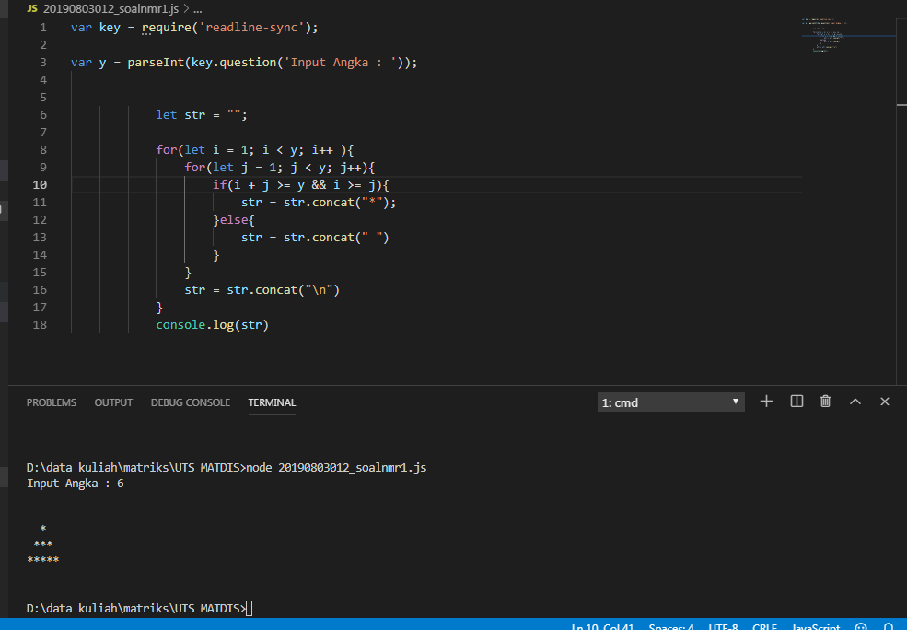

var key = require('readline-sync');

var y = parseInt(key.question('Input Angka : '));

            let str = "";

            for(let i = 1; i < y; i++ ){

                for(let j = 1; j < y; j++){

                    if(i + j <= y && i >= j){

                        str = str.concat("*");

                    }else{

                        str = str.concat(" ")

                    }

                }

                str = str.concat("\n")

            }

            console.log(str)

|  |  |  |
| --- | --- | --- |
| input | i | output |
| 6 | 2 | * |
|  | 3 | *** |
|  | 4 | ***** |
|  | 5 | ******* |
|  | 6 | ********* |

**Soal nomor 2**

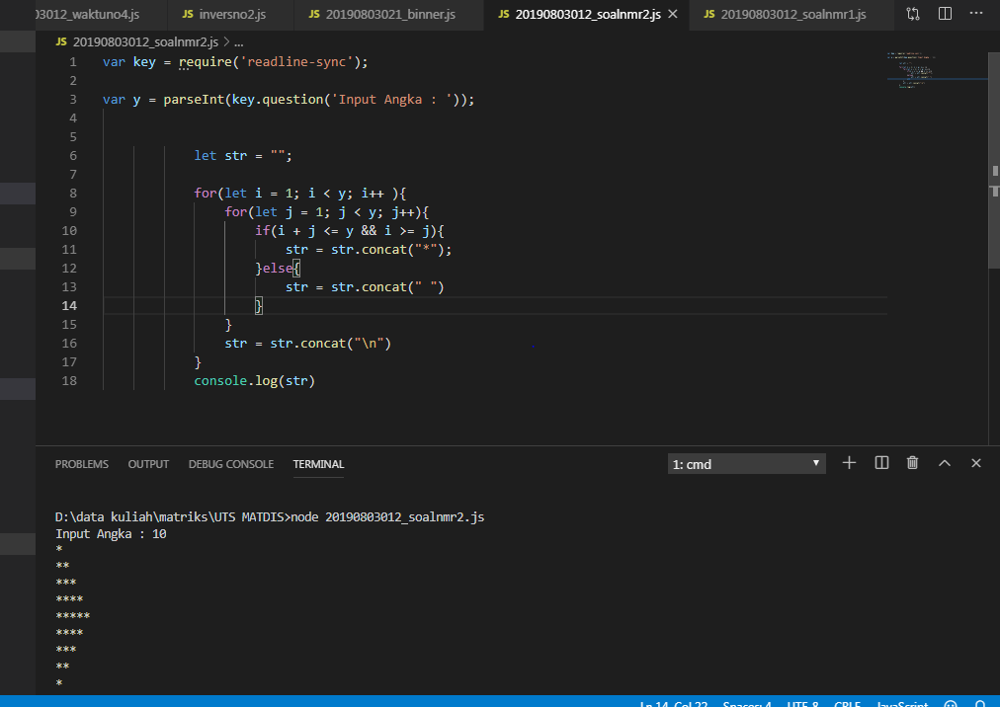

var key = require('readline-sync');

var y = parseInt(key.question('Input Angka : '));

            let str = "";

            for(let i = 1; i < y; i++ ){

                for(let j = 1; j < y; j++){

                    if(i + j <= y && i >= j){

                        str = str.concat("*");

                    }else{

                        str = str.concat(" ")

                    }

                }

                str = str.concat("\n")

            }

            console.log(str)

|  |  |  |
| --- | --- | --- |
| input | i | output |
| 6 | 2 | * |
|  | 3 | ** |
|  | 4 | *** |
|  | 5 | ** |
|  | 6 | * |